**School Improvement Plan**

**2024 - 2025**

**JR Neal, Principal**

PCSD VISION

PCSD MISSION

***The vision of the Paulding County School System is to prepare ALL students for success today and tomorrow.***

***Engage. Inspire. Prepare.***

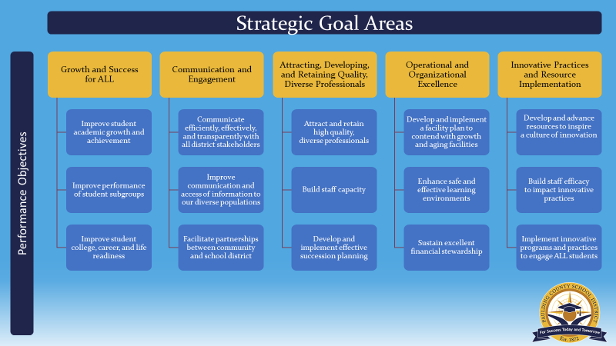

SCHOOL MISSION & VISION

**Our Mission**

South Paulding Middle School seeks to create a safe and positive environment in which all stakeholders work together to help students be ready for graduation, ready for work, and ready for life.

**Our Vision**

Our vision is to create lifelong learners through rigor, relevance, and relationships.



|  |
| --- |
| ***South Paulding Middle School Improvement Action Plan***  ***SMART Goal 1: Implement rigorous instruction to increase the percentage of students scoring at proficient learner or above on ELA GA Milestones from 40.7% to 46% the by end of the 2024 - 2025 school year.***  ***More specifically:***  ***6th grade from 38.2% to 43.2%***  ***7th grade from 42.2% to 47.2%***  ***8th grade from 42% to 47%*** |

| **Strategic Goal Area** | **Initiatives/Action Steps** | **Process Goals**  **(Guide your Action Steps – benchmarks along the way)** | **Person(s)**  **Responsible** | **Monitoring** | |
| --- | --- | --- | --- | --- | --- |
| **Implementation**  **(Artifacts/Evidence)** | **Effectiveness**  **(Formative Data)** |
| **Strategic Goal 1**  Growth and Success for ALL | Teachers will utilize rigorous Tier I instruction and establish high leverage instructional practices that will be used to increase rigor. | Schedule focus walk in October 2024 with Department Heads be utilized to allow for feedback and next steps.  Rubrics will be developed to guide the focus walks. | ALL teachers | Focus walk schedules  Focus Walk rubrics | Percentage of observations reflecting the increase in rigor on the rubric. |
| **Strategic Goal 1**  Growth and Success for ALL | Utilize differentiated, research-based reading and writing strategies across all content areas daily as measured by mastery of common assessments | ELA teachers will utilize the MyPerspectives resources to guide their lessons.  Teachers will implement strategies such as ARS, KTL, and/or graphic organizers daily.  Teachers will build common assessments during PLCs and evaluate these assessments for mastery as evidenced by gradebook and PLC data discussions | ELA, Science, and Social Studies teachers  Administration | Collaborative meeting minutes  Gradebooks  Common Assessments  Lesson Plans | Administration will monitor/analyze PLC summative and formative common assessment grade data. |

|  |
| --- |
| ***South Paulding Middle School Improvement Action Plan***  ***SMART Goal 2: Increase the percentage of students scoring at proficient learner or above on 8th grade Science Georgia Milestones from 6.4% to 17% and on 9th grade Physical Science Georgia Milestones from 36.5% to 60% by the end of the 2024 – 2025 school year.*** |

| **Strategic Goal Area** | **Initiatives/Action Steps** | **Process Goals**  **(Guide your Action Steps – benchmarks along the way)** | **Person(s)**  **Responsible** | **Monitoring** | |
| --- | --- | --- | --- | --- | --- |
| **Implementation**  **(Artifacts/Evidence)** | **Effectiveness**  **(Formative Data)** |
| **Strategic Goal 1**  Growth and Success for ALL | Calendar coaching cycle observations. | Meet monthly to calendar coaching cycle observations. | Administration | Coaching Cycle calendar  Percentage of completed observations | Classrooms with regular feedback have seen an increase in student average summative grades since the feedback began. |
| **Strategic Goal 1**  Growth and Success for ALL | Conduct non-evaluative observations with Science teachers.  6th grade: Leachman and Tillery  7th grade: Havron and Williams  8th grade: Holland and Wilday | Coaching cycle every four weeks with feedback that includes glows, grows, and next steps.  Monitor common assessments. | Administration | District Science walkthrough form  Coaching Logs in KickUp | Classrooms with regular feedback have seen an increase in student average summative grades since the feedback began. |

|  |  |  |  |  |  |
| --- | --- | --- | --- | --- | --- |
| ***South Paulding Middle School Improvement Action Plan***  ***SMART Goal 3: Implement non-punitive interventions in the classroom to decrease the number of ISS days and the number of OSS by 10% as measured by office referrals in SWISS data system by the end of the 2024-2025 school year******. More specifically, the number of ISS days will be reduced from 529 to 476, and the number of OSS days will be reduced from 398 to 358.*** | | | | | |
| **Strategic Goal Area** | **Initiatives/Action Steps** | **Process Goals**  **(Guide your Action Steps – benchmarks along the way)** | **Person(s)**  **Responsible** | **Monitoring** | | |
| **Implementation**  **(Artifacts/Eidence)** | **Effectiveness**  **(Formative Data)** | |
| **Strategic Goal 4**  Enhance Safe and Effective learning Environments | Regular review of discipline and suspension data with Leadership Team and BESST Team | The Administration will meet monthly with the Leadership Team and BESST Team to identify discipline patterns and trends and determine areas in need of improvement | JR Neal  Leadership Team  BESST Team | SWIS data | Administration will monitor =discipline through SWIS data and share with staff | |
| **Strategic Goal 4**  Enhance Safe and Effective learning Environments | Utilize non-punitive strategies to help create authentic relationships in diverse classrooms | BESST Team will review monthly and reflect on discipline data and review PBIS points awarded through the Minga app.  Students will have opportunities to spend their points by participating in Points to Play during homeroom, Panther Parties every 9 weeks, and other various activities. | ALL Teachers  Administration  BESST Team | Discipline Boards  PBIS points reports  Weekly reflection goal during collaboration | Administration will monitor discipline through SWIS data and the PBIS rewards app, as well as track growth and participation in with the PBIS reward redemptions. This information will be shared with staff at monthly staff meetings. | |
| **Strategic Goal 4**  Enhance Safe and Effective learning Environments | Review grade and attendance data with every discipline assignment | Administration will conference with students with discipline referrals regarding their grades and attendance | JR Neal  Sandra Wood  Julian Hicks | Discipline/Data form  IC grade and attendance data | Administration will monitor pre and post discipline data of the select students | |

**South Paulding Middle School Professional Learning Plan**

| **Professional Learning Strategy/Support**  (**Should be connected to effectiveness monitoring of action steps in the SIP**) | **Audience** | **Presenter** | **Timeline** | **Monitoring** | |
| --- | --- | --- | --- | --- | --- |
| **Implementation** | **Effectiveness** |
| Teachers will be given weekly protected time to collaborate and communicate through their subject area PLCs to assure consistency with standard driven curriculum and common rigorous assessments among subject areas and grade levels | ALL content area teachers | Grade level departments  Sandra Wood, ELA  JR Neal, Science  Julian Hicks, SS  Trina Wheeler, Math | Every Wednesday and Thursday during grade level planning throughout the school year | Collaboration minutes  Common Assessments | Administration will attend weekly collaboration PLCs and monitor the delivery of rigorous lessons that differentiate, remediate, and accelerate to maintain student growth. |
| Provide Title II days for Science teachers to unpack the standards and create rigorous common assessments. | 6th – 8th grade Science teachers | Trina Wheeler, EAC  Tracy Sellars, Science Curriculum Coordinator | By October 30, 2024 | Georgia Science Standards  Common assessments  Sign in sheets  Agendas | Teachers and Administration will monitor/analyze data from common assessments |
| Teachers will participate in professional learning based on implementing rigorous Tier I instruction in the classroom. | ALL teachers | Irina Keith, Gifted and Advanced Programs Coordinator  Trina Wheeler, EAC | December 17, 2024  February 25, 2025 | Agendas  Sign-In sheets  Various hand-outs and resources | Administration will monitor/analyze Beacon data and data from common assessments. |
| Teachers will participate professional learning based on utilizing technology in the classroom.  building authentic relationships in diverse classrooms, etc. | ALL certified teachers | Breanne Wood, Instructional Technology Coach | 8/20/24  10/1/24  1/7/25  3/4/25 | KickUp  Agendas  Handouts | Administration will monitor effectiveness through weekly walkthroughs. |
| Teachers will participate in a monthly PLC book study on the power of positivity and building authentic relationships in diverse classrooms. | ALL teachers | Various presenters – Grade level teachers will present each month | 9/17/24  10/29/24  11/12/24  12/3/24  1/28/25  2/11/25 | “The Energy Bus” by John Gordon  KickUp  Various handouts and resources | The BESST team and Administration will monitor discipline through SWIS data and share with staff |

Supports that may be included:

* PLC work
* Coaching sessions with Individual Teachers
* Mentors
* Online Professional Learning Opportunities
* Paraprofessional PL Opportunities
* Ongoing District or School provided PL